Use Case Documents

|  |  |
| --- | --- |
| **Name:** | Start Up & Show Suggested Items To Buy |
| **Summary:** | The user selects the app and the main page loads with purchase suggestions. |
| **Version:** | 1.0 |
| **Preconditions:** | 1. System Displays the Shopping App Icon |
| **Triggers:** | 1. User Selects the Shopping App Icon |
| **Main Success Scenario:** | N/A |
| **Alternative Success Scenarios:** | N/A |
| **Postconditions:** | 1. System Displays Shopping Icon.  2. Systems Displays The “Home Page”.  3. System Displays Suggested Items to Purchase and their icons.  4. Systems Displays the Main Shopping Banner.  5. System Displays Search Bar and Search Icon.  6. System Displays Drop Down Menu Icon.  7. System Displays Options of Drop Down Menu. |
| **Business Rules** | N/A |
| **Notes:** | N/A |
| **Author:** | Robert Fredrickson |
| **Date:** | 11/10/2017 |

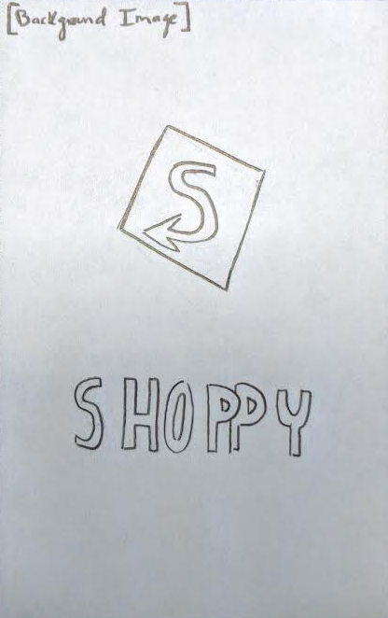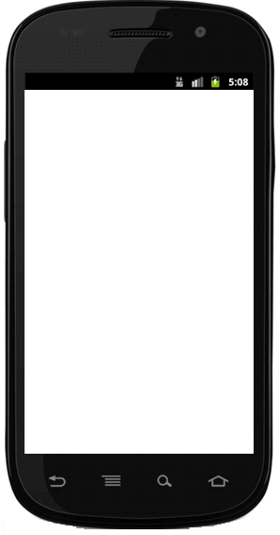

|  |  |
| --- | --- |
| **Name:** | Find Products To Buy |
| **Summary:** | The user searches for items to purchase. |
| **Version:** | 1.0 |
| **Preconditions:** | 1. System Displays Suggested Items to Purchase and their icons.  2. Systems Displays the Main Shopping Banner.  3. System Displays Search Icon.  4. System Displays My Account Icon  5. System Displays Favorites Icon |
| **Triggers:** | The user select the search icon. |
| **Main Success Scenario:** | 1. User enters item name.  2. User selects the “GO” icon. |
| **Alternative Success Scenarios:** | N/A |
| **Post conditions:** | 1. System Displays Items Related to the keyword that the user has entered in the search bar.  2. System Displays Item’s Icons.  3. System Displays Item’s Price.  4. System Displays “add to bag” Icons. |
| **Business Rules** | 1. Item name cannot be blank.  2. Multiple words are acceptable.  3. Item name cannot only be white spaces. (Tab, space space, etc.) |
| **Notes:** | N/A |
| **Author:** | Robert Fredrickson |
| **Date:** | 11/11/2017 |

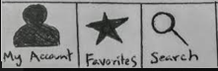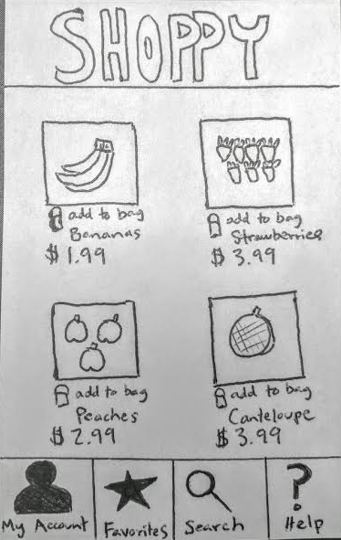

|  |  |
| --- | --- |
| **Name:** | Place An Order |
| **Summary:** | The user has a view in which they can see the summary of items and lead to checkout |
| **Version:** | 1.0 |
| **Preconditions:** | 1. System Displays a display of items chosen along with quantity.  2. System Displays the Main Shopping Banner.  3. System Displays the subtotal.  4. System Displays the checkout button.  5. System Displays search icon at top right  6. System Displays menu icon at top left.  7. System Displays estimated tax and shipping. |
| **Triggers:** | The user selects the checkout button. |
| **Main Success Scenario:** | User reviews the order and selects checkout. |
| **Alternative Success Scenarios:** | N/A |
| **Postconditions:** | N/A |
| **Business Rules** | N/A |
| **Notes:** | N/A |
| **Author:** | Robert Fredrickson |
| **Date:** | 11/14/2017 |

